# Task 1

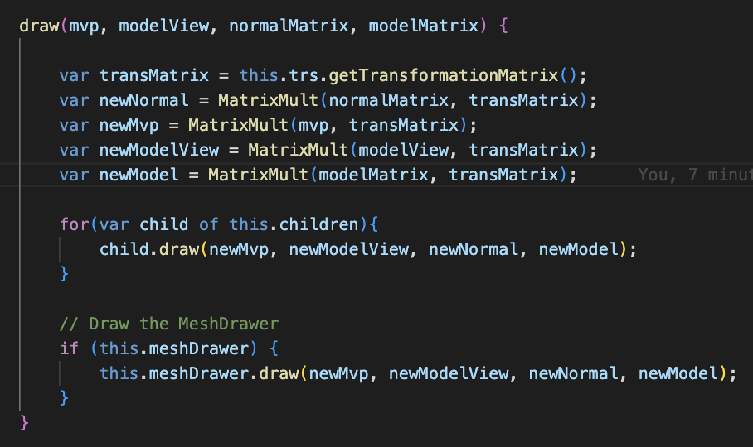In this task, the goal was to implement the draw function in the SceneNode.js file to facilitate the correct rendering of nodes in the scene graph. The primary objective was to ensure that transformations applied to parent nodes are correctly propagated to their child nodes.

I first got the transformation matrix using getTransformationMatrix function. Then I calculated the transformed normals by multiplying the normal matrix and transformation matrix. I did these to mvp and model view to get the tranfsormed versions. After that I created a loop and calculated the transformations for childs of the norde.

# Task 2

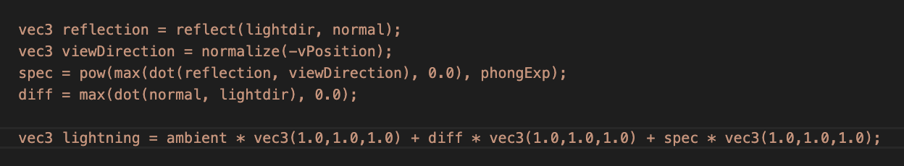For implementing diffuse and specular lightning, I got the reflection by using the reflect function with the given light direction and the normal. Then I normalized the -vPosition and got the view direction. For specular lightning I used phongExp if dot product of the reflection and view direction. For diffuse lightning I took the dot product of normal and light direction. Then I summed all the lights.

# Task 3

Adding Mars was a very easy task. I just copied the creation of earth and changed translation and scaling. Then I added the given rotation.

